
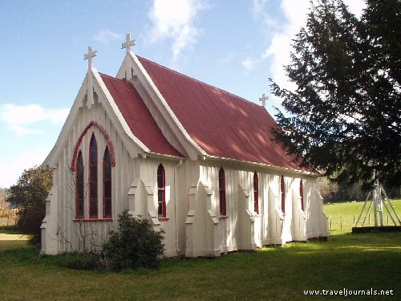

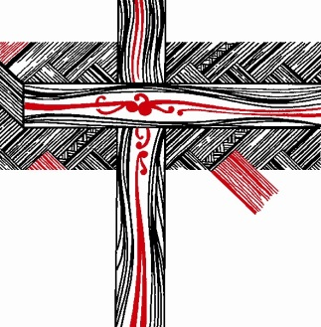

Report to General Synod 2016

By the Councillors for the Anglican Women’s Studies Centre

Council’s Objectives as from the Canon
Canon XXV of the Council for Anglican Women’s Studies 2006
- To establish a Women’s Studies Centre to support or provide theological education for women and to encourage research into issues of importance to and for women as these arise for the Church / Te Hāhi Mihinare
- To act as the governing body of the Women’s Studies
- To enable women within each Tikanga to find appropriate support and mentoring in relation to theological education
Anglican Women’s Studies Centre
The Anglican Church in Aotearoa New Zealand and Polynesia
- To work towards ensuring that theological education is available to all women
- To promote the establishment of new and targeted scholarships for women undertaking theological study particularly at post-graduate levels and actively to encourage women to apply for such scholarships as may be available through the church
- To encourage research that monitors, informs and critiques attitudes and behaviour towards (i) the roles and status of women within the church (ii) equitable access for women to theological education and resources for ministry
- To identify and develop networks and support structures to empower women as they seek to find a place within the Church / Te Hāhi Mihinare.
- To recognise the diverse needs of women as they seek to grow and heal, and promote structures / programmes that respond to these needs
- To provide in its own organisation a model for networking and for non-hierarchical and ecumenical ways of working
- To offer leadership development opportunities for women in all spheres of church life.
Councillors
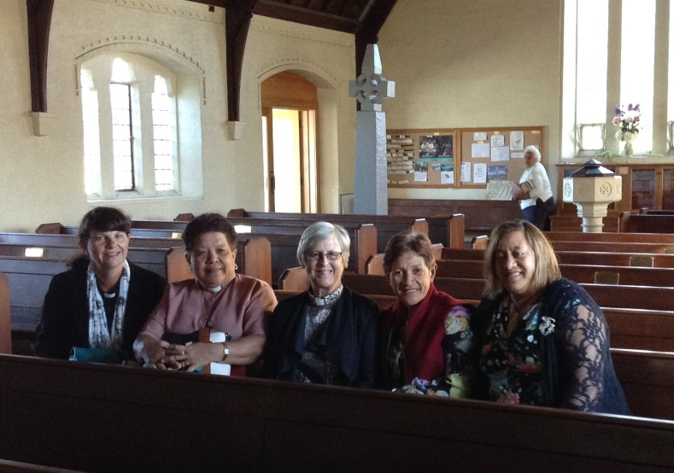

AWSC Councillors at St Faith’s Anglican Parish in Hokitika in February 2015.

From Left: Tikanga Pakeha – The Venerable Carole Hughes, Diocese of Auckland (AWSC Council Convenor); Tikanga Polynesia – The Revd Amy Chambers, Diocese of Polynesia; Tikanga Pakeha – The Revd Erice Fairbrother, Diocese of Waiapu; Tikanga Maori – The Revd Numia Tomoana, Hui Amorangi o Te Tairawhiti; Tikanga Maori – The Venerable Mere Wallace, Anglican Maori Diocese of Te Waipounamu; Absent: Tikanga Polynesia - Revd Evelini Langi, Diocese of Polynesia.

The Council for Anglican Women’s Studies continues to strive to meet the above mandate that General Synod has set for us. The Council is constituted by two elected women from each tikanga, and an administrator, who meet at least three times a year and also keep in touch regularly by electronic means.

Link Women from each Hui Amorangi/Diocese

We also strive to hear the voices and include women from local contexts across Aotearoa, New Zealand and Polynesia. Each Hui Amorangi and Diocese appoints a woman to represent the Council for Anglican Women’s Studies in their place. This involves attending a yearly link meeting, attending the annual Women’s Studies hui, distributing correspondence and publications of the Council, and promoting the work of the Council. We are also encouraging the link women to gather local women, whether that is for an education day, a meeting to discuss local theological issues for women, or simply catching up over a meal. It is up to each link woman as to determine what is appropriate for the context.
The following are our link women across the province:
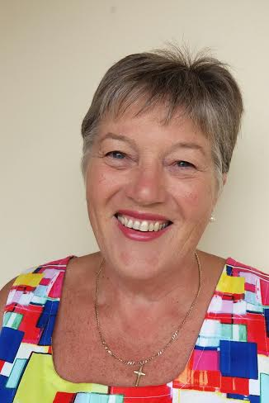
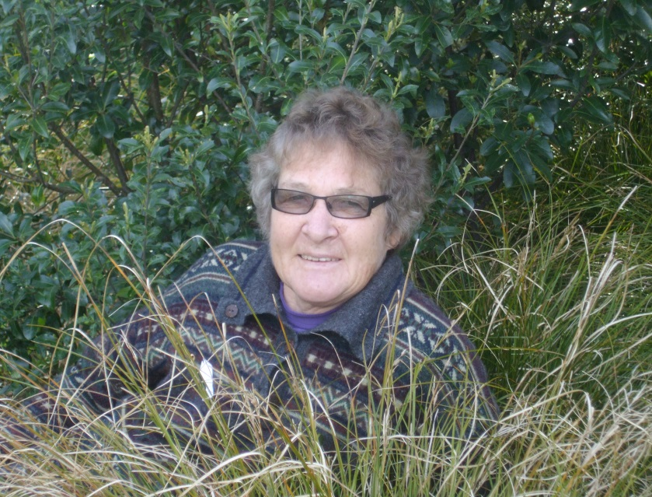
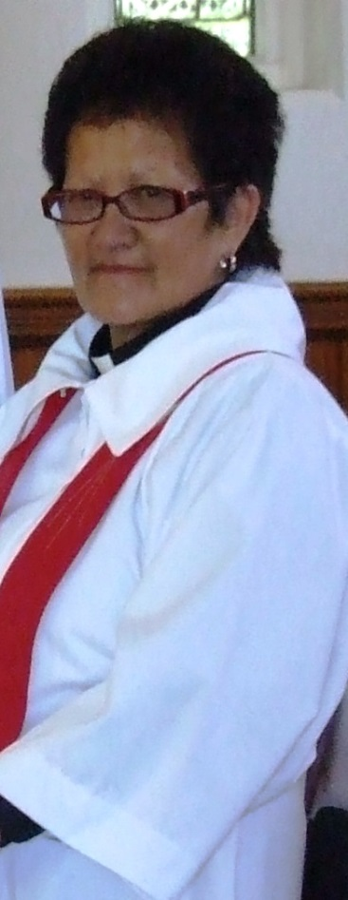
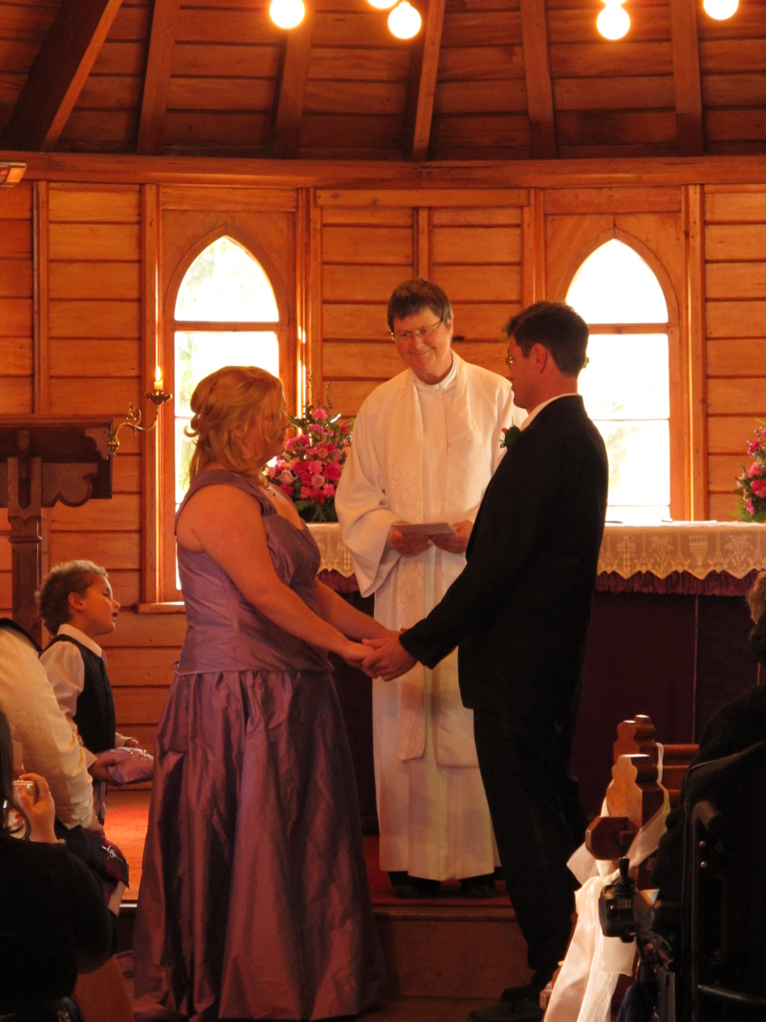
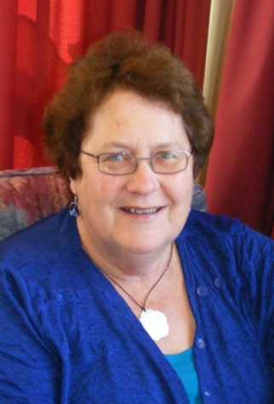
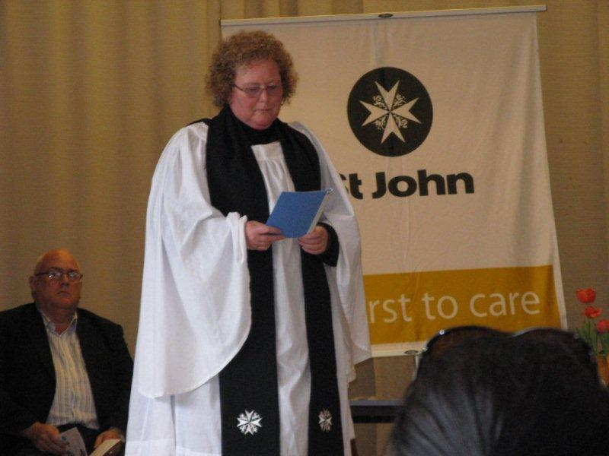
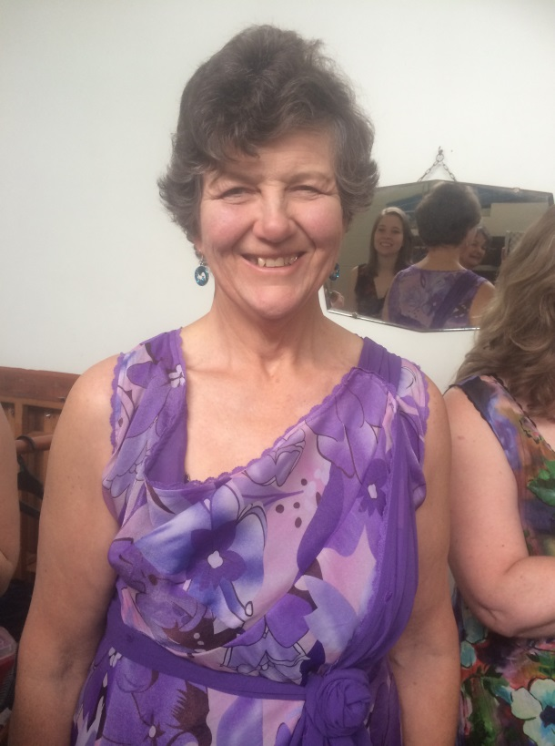
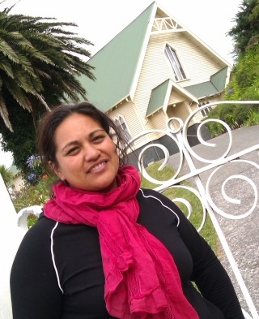
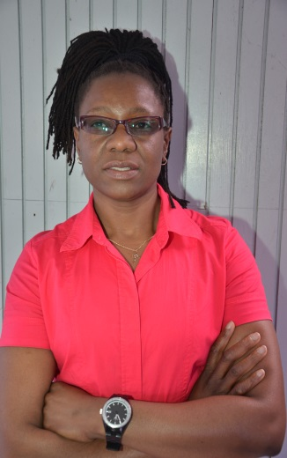
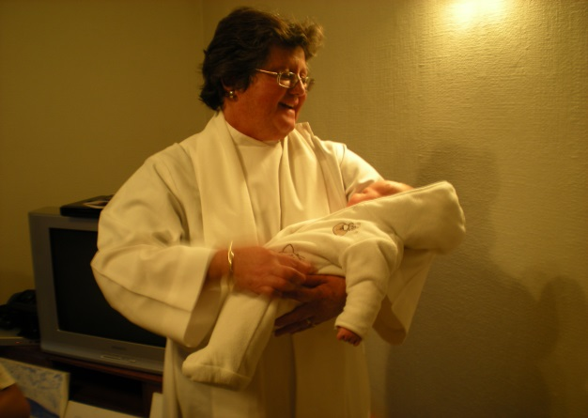

A
B
C

D
E
F
G
H
I
J

- Kaye Dyer - Diocese of Nelson
- Jenny Campbell - Diocese of Dunedin
- Revd Jenny Chalmers - Diocese of Wellington
- Revd Rosemary Carey - Diocese of Waiapu
- Revd Leonie Joseph – Hui Amorangi o Te Upoko o Te Ika
- Revd Jenni Carter – Diocese of Christchurch
- Venerable Val Riches – Diocese of Waikato & Taranaki
- Revd Jenny Quince – Hui Amorangi o Te Taitokerau
- Revd Nyasha Gumbeze – Diocese of Auckland
- Ruihana Paenga – Hui Amorangi o Te Tairawhiti

Please Note: Photo not supplied for The Venerable Mabel Grennell, Anglican Maori Diocese of Te Waipounamu. At the time of writing this report, Rahera Biddle resigned and Hui Amorangi Manawa o te Wheke are in the process of appointing a new representative. There is no AWSC Link Representative appointed for the Diocese of Polynesia.

Annual Provincial Hui
&
Leading?
Church,
Women
2014 Treasuring Women in Ministry Provincial Hui
"Church, Women & Leading?”

St John’s Theological College, Auckland
29th September – 1st October 2014

The Anglican Women’s Studies Council hosted its second offering in the Treasuring Women in Ministry Provincial Hui programme from 29th September to 1st October 2014 at St John’s Theological College in Auckland. This was a non-residential hui offering the opportunity to all lay and ordained Anglican women in ministry to be together in worship, prayer and discussion. Being able to gather as three tikanga, to learn from each other and grow together, at the centre of three tikanga church life at St John’s Theological College is greatly appreciated by those who attend and these events help support and foster ministry relationships across tikanga.
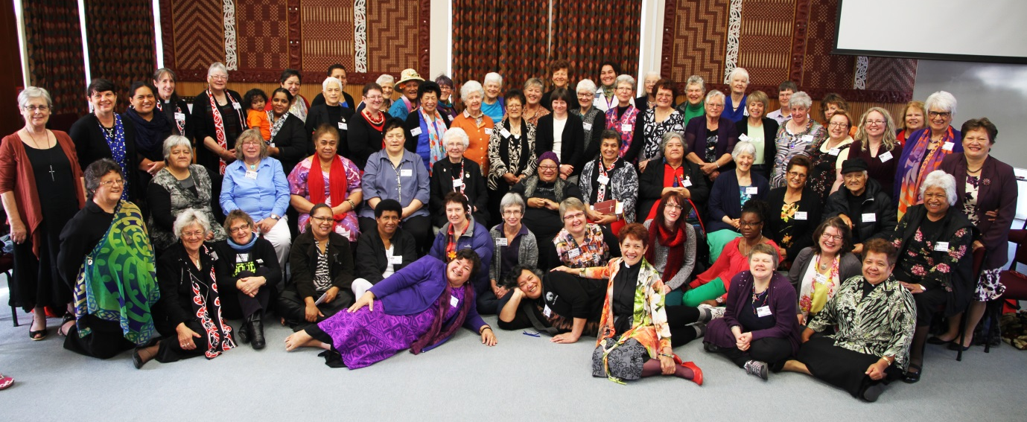
Eighty-six women registered for the event and participants took part in a number of sessions that included Bible Studies with The Right Reverend Dr Helen-Ann Hartley and the SJC Chaplain, Reverend Eseta Mateiviti-Tulavu and former tikanga Polynesian Councillor Reverend Brenda Sio; Our Voices led by The Venerable Carole Hughes; Grass-Root & Flax-Root Ministries with Reverends Amy Chambers, Jenni Carter and Pane Kawhia; Life Stages & Ministry with Reverend Erice Fairbrother; Different Leadership Styles with The Venerable Carole Hughes and Reverend Jacqui Patterson; Leadership Challenges When Straddling Two Cultures with Emeline Afeaki Mafieo; Leading a Community Through A Time of Crisis with Reverend Jenny Chalmers; Prayer Life & Fasting with Reverend Nyasha Gumbeze; Wellness, Wholeness in 3 Tikanga with Reverends Numia Tomoana and Jenny Quince, and finally Weaving Ribbons of Unity with Reverend Jenny Quince.

The Council would like to thank each presenter for volunteering their time and sharing their knowledge with us all, it was greatly appreciated. The over-riding response from those gathered is that to be in three tikanga, with and for each other, is a wonderful opportunity not to be missed.
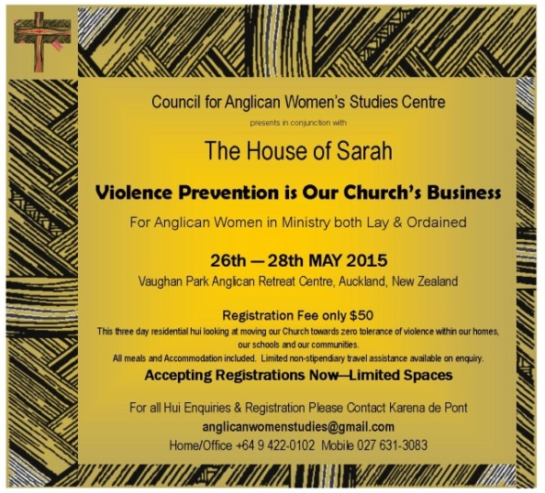
2015 Women in Ministry Provincial Hui
"Violence Prevention is Our Church’s Business”

Vaughan Park Anglican Retreat Centre, Auckland
26th – 28th May 2015

In keeping with our regular routine of offering a residential retreat style of gathering in three tikanga on alternate years, the AWSC Council collaborated with The House of Sarah to present this dynamic hui “Violence Prevention Is Our Church’s Business” in May 2015 in which 40 women attended.
This was the first hui gathering that had equal representation from each of the tikanga as each tikanga grapples with this issue that knows no economic, religious or cultural barrier.
The House of Sarah (HoS) is an AAW initiative in the Diocese of Polynesia that was established to address and advocate for violence prevention. An invitation from the AWSC Council to the House of Sarah to lead us in this hui was extended after the Council had the opportunity to visit with them when the Council’s met in Suva in July 2014.
We spent the first day of the hui getting to know one another and establishing protocols for safe story-telling and group sharing. With excellent leadership from Akanisi Tarabe, we all felt like we were in good hands to go forward with what would turn out to be a very thought provoking but positive three days. The following day, participants had the opportunity to choose four out of six workshop options: Survivors Stories, led by Nai Cokanasiga; Using the Church Structures to Enable Gender Justice & Eliminate Violence Against Women led by Reverend Sereima Lomaloma; Shining the Light on Violence led by Reverend Ann Drummond; The Role of Sarah Carers in the Community led by Nai Cokanasiga; Safe Churches, led by Reverend Sereima Lomaloma and The House of Sarah Approach to Clergy Awareness, led by Reverend Anne Drummond.
On the third day we gathered together and formed the following Hui Outcome Statement. This Statment has been presented to the General Synod Standing Committee and it is the Council’s hope and prayer that the wider Church learns from our initiative and is proactive in upholding the values and recommendations.
Council for Anglican Women’s Studies - 2015 Women in Ministry Three Tikanga Hui
Violence Prevention is Our Church’s Business
HUI OUTCOME STATEMENT
We, the participants of the Hui on ‘Violence Prevention is Our Church’s Business’ organised by the Anglican Women’s Studies Council held at Vaughan Park Anglican Retreat Centre, Auckland from May 26th – May 28th 2015:
AFFIRM that in working towards transforming unjust structures, violence prevention is our church’s business;
Therefore we recommend:
Recommendations
- The implementation and compliance with Motion 19 of General Synod/Te Hinota Whanui 2014 Safe Church Charter and Policy Group at Hui Amorangi/Diocesan level
- That we recognize that a key responsibility of the church is to the survivors of abuse as outlined in the Anglican Communion Safe Church Charter.
- Title D Canon 1– That awareness is raised of the Canon and in particular education around Title D Canon 1 and Canon 2 at all Church levels
- Provision of adequate training for appropriate people, clergy and lay to care, support and refer victims/survivors of violence.
- That the church shall be a strong and consistent advocate for prevention of violence against all people particularly women and children as an Anglican Church initiative or in partnership with others.
- That each Hui Amorangi/Diocese provides a mechanism to disseminate relevant information resourcing parishes and ministry units to address the issue of violence against all people particularly women and children e.g. Break the Silence, 16 Days of Activism, White Ribbon Campaign, Community Mobilisation.
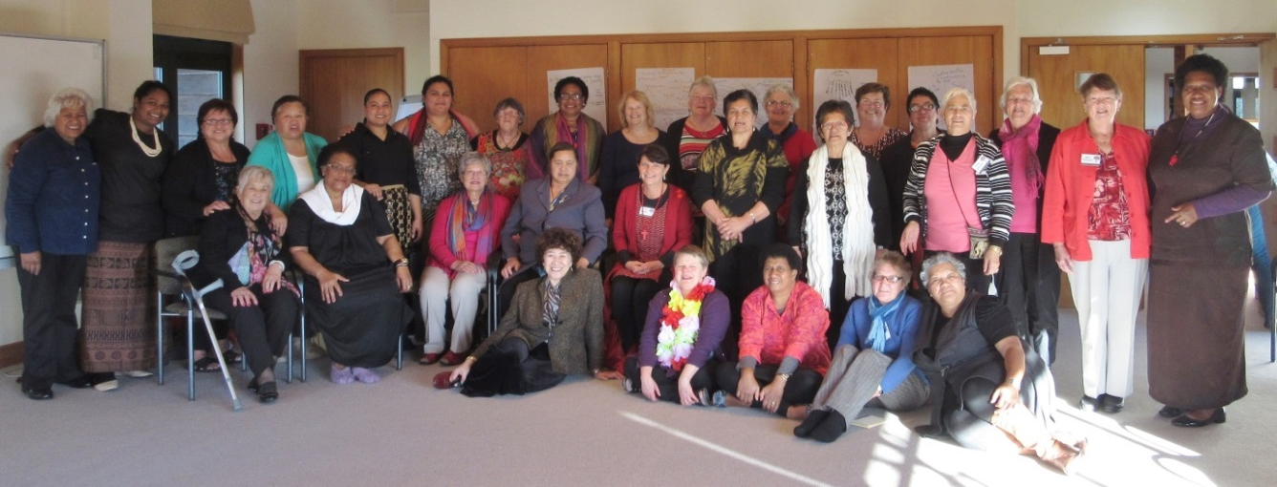
Publishing
Monthly Newsletter –
The AWSC publishes and distributes via email a monthly newsletter. This newsletter is distributed throughout the Province and Communion via the International Anglican Women’s Network. It is well received and contains articles, poems, sermons, book reviews, and thesis articles etc., submitted from Anglican women throughout our Province. The newsletter is a vehicle that the Council can use to show its commitment to encouraging and enabling women’s voices and perspectives from across the diversity of the Church to be shared more widely. We acknowledge that women’s experiences of church differ considerably and that resultant theological perspectives also differ considerably. In general the AWSC does not exercise editorial control; rather we welcome as many voices as are willing to contribute.
Back copies of the newsletter can be found on the Women’s Studies webpage on www.anglican.org.nz
Books –
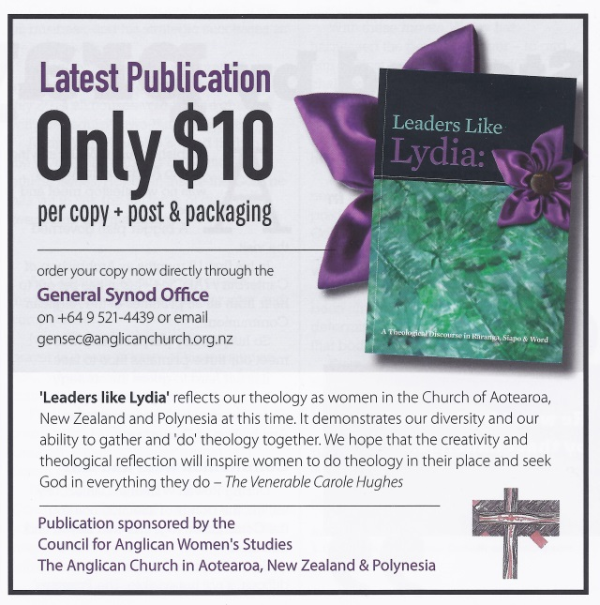
In September 2014 the AWSC Council launched its latest publication based on the work, discussions and methodology from the 2013 Hui ‘Leaders Like Lydia: A theological Discourse in Raranga, Siapo & Word’.
It was a real pleasure to have so many of the contributors to the book present at the book launch to share in our celebration. Many of the contributors had never had their work published before and so the joy in seeing their work printed in a beautifully presented book designed by Marcus Thomas Design was a delight to behold.
The work presented from the three hui workshops led by the Reverends Brenda Sio and Amy Chambers for Saipo, Reverend Erice Fairbrother for Word Weaving and The Venerable Mere Wallace for Raranga feature throughout the book and delighted many of the participants from the 2014 Hui who also joined in the celebrations.
The Council are very appreciative of Bishop Victoria Matthews support and for writing such a lovely endorsement which features on the back cover. We would also like to take this opportunity to acknowledge our thanks to the Reverend Lynne Frith, firstly for accepting the invitation for being our Hui Word Catcher and then the additional challenge of editing all the work submitted for this publication.
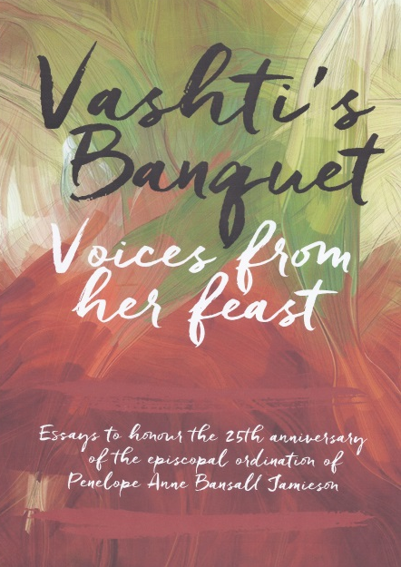
Vashti’s Banquet: Voices From Her Feast
Essays to honour the 25th anniversary of the episcopal ordination of Penelope Anne Bansall Jamieson
This publication project is currently at Marcus Thomas Design in the final stages of preparing for printing. The following chapters are a result of two years hard work by Reverends Erice Fairbrother and Jenny Chalmers who have invited contributors from across the Communion to honour the 25th Anniversary of the Episcopal ordination of the first woman Diocesan Bishop, The Right Reverend Penny Jamieson.
Since there is a number of high profile Anglicans who have contributed to this publication the Council expects that this resource will have an international appeal. The following contributors and their essays no doubt will confirm this opinion.
- Claire Brown
Come Holy Spirit: The nomination and election of the seventh Bishop of Dunedin, The Right Reverend Penny Jamieson
- Susan Adams
Struggle and Hope
- Jenny Chalmers
When we remembered Zion’: How the church redefined ‘Israel’ and ‘Zion’
- Jenny Dawson
Baptism doth represent unto us our profession
- Paula Gooder
On getting from there to here: Reflections on the journey to the consecration of Women as Bishop’s in the Church of England
- Mary Gray-Reeves
Beyond the Transaction
- Carole Hughes
Disturbing Leadership
- Helen Jacobi
Speaking Up: Reclaiming our Voice in God’s World
- Katharine Jefferts Schori
Christians and Creation: Freedom, Lament, Dominion, Vocation?
- Victoria Matthews
Spirituality and the Office of a Bishop
- Philip Richardson
Chalices and Gumboots: Developing Sustainable Rural Ministry
- Brenda Sio
Ecumenism and sisterhood comes alive in Community

Nicola Slee

On Getting Here from There: Reflections on the Journey to the Consecration of Women as Bishops within the Church of England
- Storm Swain
A moment of “Tender Loving Defiance.” Reflections on the 40th anniversary of the ‘irregular’ ordination of women to the priesthood in the Episcopal Church.
- Jenny Te Paa Daniel
Culture, Gender and Gospel Imperatives in the Pacific: A Theological Critique and Challenges for Authentic Change
- Anne Van Gend
Hosea and “engaging with confidence” in our society

Mentoring
2014
The AWSC Mentoring Programme is a multi-faceted programme where the Council endeavours to support women in furthering their theological studies, or ministry and professional development as and where needed. The programme is intended to empower women to achieve the academic qualifications and leadership experience to enable them to both ‘qualify’ and to be confident in their ability and deservedness to contribute to discussions, debates and decision making at national and international level of the churches activities. The Council also recognizes that local mentoring opportunities exist to foster inter-tikanga relationships, methodology and practices that will benefit all that participate through inter-tikanga formation and educational exchanges. The need to mentor women into the work of the Council with the view to building future leadership capacity is part of the AWSC kaupapa.
In February 2014, the Council enabled the Archbishops to respond to the call to send a young women and a chaperone to the 58th Session of the United Nations Commission on the Status of Women in New York. The Council covered the costs of sending Ana Maria Lamositele from Samoa who was chaperone for Kaufo’ou Leveni from Tonga. Both expressed their gratitude to be offered the opportunity to participate in such a challenging event. Kaufo’ou Leveni’s report was published in the May 2014 AWSC newsletter and she is now working with groups in Tonga as a result of her experience in New York. Both of these women were invited to attend and speak at the AWSC hui ‘Church, Women & Leading?’ but were unable to due to work commitments.
The May 2014 edition of the newsletter also included the report from Reverend Dr Eleanor (Ellie) Sanderson who was supported through the Mentoring Programme with a contribution towards her travel costs so she could take up the invitation to be the keynote speaker for the Anglican Women at Prayer – Weaving Our Bonds of Affection conference in March at Virginia Theological Seminary, USA. The excellent resource pack developed from this conference was gifted to AWSC for our future use and referral. Ellie’s key note speaker invitation was a direct result from her essay inclusion in the AWSC publication “Our Place, Our Voice” which reinstated the benefits of promoting women’s writing.
In June 2014 both Reverends Erice Fairbrother and Jenny Chalmers attended the Prevent People Trafficking International Conference at the Royal NZ Police College in Porirua, Wellington. The AWSC interest stemmed from the excellent feedback received from Sarah Stevens who attended the 2011 UNCSW about this topic. Also IAWN asked us to attend on their behalf and the conference report from Erice and Jenny was provided to IAWN and distributed around the Communion.
While in Suva, the Council held a one day workshop open to all. This workshop included a liturgical session looking at different approaches to studying the bible, a session combining raranga techniques using local foliage and a session on the use of poi weaved together with song, as Numia Tomoana put it in our August 2014 AWSC Newsletter ‘contextual theological and cultural fulfilment’. The Council also visited with women from the parish at Holy Trinity Cathedral to talk about the work that the Council does and discuss their needs and how we may support them.
During July 2014, Erice Fairbrother, on behalf of the Council responded to the invitation of Archbishop Winston to spend time in the Archdeaconry of Tonga to provide mentoring and training. One of the specific requests was to model ordained women’s ministry from an experienced priest and whilst there, Erice was also able to provide mentoring for chaplaincy, preaching and Religious Education teaching. All in all, it was a very busy but fulfilling time and her visit has resulted in ongoing support and mentoring as required.
2015
Following on from Reverend Erice Fairbrother’s mentoring visit to Tonga in 2014, the Council continued to support the professional development of Sr Mele Fehoko Tuatuaa in her role as School Chaplain. On behalf of the AWSC Council, Erice initiated negotiations with the Dioceses of Wellington and Waiapu to provide an opportunity for Sr Mele to experience school chaplaincy in each of their Diocese after she had attended the School Chaplaincy Conference. Sr Mele also then stayed with Reverend Numia Tomoana in Hui Amorangi o Te Tairawhiti and while there, she visited with the School Chaplains of Te Aute College and Hukarere College and talked through with them how they adapted the school curriculum to meet the needs of their context. This example of professional development mentoring reflects how working together in support of each other through sharing our individual gifts is an excellent way of resource sharing across the tikanga.
With the relaunching of EFM throughout New Zealand, AWSC has been able to assist 14 non-stipendiary Anglican women to participate in this theological studies programme. At the last Link Representative meeting in November, the support of EFM was discussed and how our tikanga Polynesian and Maori sisters can also encourage women of their tikanga to apply for funding assistance with parish based theological studies programmes if and when required.
United Nations Commission on the Status of Women (UNCSW)
2014
In 2014, the Archbishops were asked to send a young women and a chaperone to the 58th session of UNCSW. The theme for this year’s conference was “Challenges and Achievements in the Implementation of the Millennium Development Goals (MDG) for Women and Girls”. We were very fortunate that with the blessing of the Archbishops this Province was able to send Kaufo’ou Leveni from Tonga as our young delegate and her chaperone, Ana Maria Lamositele from Samoa. The AWSC assisted with covering the costs for sending the chaperone to New York for two weeks. For two young women, this represented a once in a lifetime experience that truly broaden their understanding in social and economic global issues relating to women and young girls.
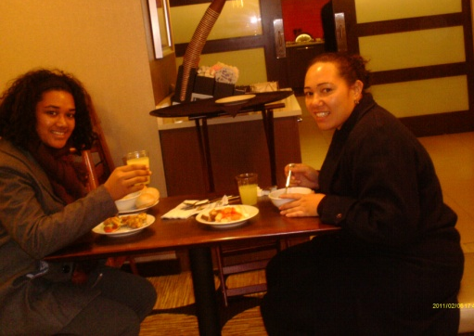
The conference orientation brought home to Kaufo’ou and Ana Maria that this conference is a huge event that encompasses all faiths, although Anglicans are well represented, and many NGO’s from around the globe. They were overwhelmed to discover that there were so many sessions, parallel and side events happening all at the same time and it was a matter of choosing relevant areas for discussion that they would like to attend, something that they could relate to back in their own countries and communities.
Having a young Pacific Island woman chaperone to accompany a young Pacific Island woman delegate was very appreciated, as Kaufo’ou said “This trip has broadened my understanding in various issues relating to young women and girls all around the world that I never knew exist. During various discussions there were some issues and terminology that I did not understand and was new to my knowledge, having Ms Ana as the chaperone she was able to explain and provide examples from a Pacific point of view that made it easy for me to understand the content of the discussions. Over the past two weeks we became very close and developed a sisterhood relationship, not only that she was able to be my mentor but we were also able to have fun together, laugh and share ideas on various discussions that took place during the meeting. Thank you once again for selecting Ms Ana as my chaperone she was a great help to me”.
In her report, Kaufo’ou recommended that at upcoming youth gatherings they talk about MDG’s so they know what is happening not only in their own environment but also the world. She would like to see the Church encouraging and supporting youth to participate in these types of forums to build their self-esteem and knowledge on global issues affecting young women and children as this involvement would help develop their character to become leaders in the Church and in our communities. Her hope is that young people participate and volunteer in the Centres that help women and children who have been affected by violence, family planning, hospital care or any other area where they can help our community improve in the future.
She acknowledged that this experience has broadened her knowledge tremendously and she now has increased empathy for others who come from a different perspective to an issue grown from a different context than her more sheltered and nurtured up-bringing.
2015
The Venerable Carole Hughes, Convenor of the CAWS attended the 59th Session of the United Nations Commission on the Status of Women, representing Churches from within the Anglican Communion! Along with world leaders from governments and civil society organisations they gathered in New York in May 2015 to welcome the review of the Beijing Platform on the status of women. In 1995 the Beijing Declaration and Platform for Action, a historic roadmap signed by 189 governments 20 years ago, set the agenda for realizing women’s rights. While there have been many achievements since then, many serious gaps remain. The current status of women reflects huge gaps, and inequities still exist right across the world.
- Ban Ki Moon (Secretary General United Nations) asks "When we hold back 50% of our population how can we expect 100% of human potential to be fully realised?” This is the time to uphold women’s achievements, recognize challenges and focus greater attention on women’s rights and gender equality to mobilize all people to do their part.
- The overall theme of this year’s International Women’s Day was the clarion call of UN Women’s Beijing+20 campaign “Empowering Women, Empowering Humanity: Picture it!”. The UNCSW global charge entitled “Planet 50-50 by 2030: Step It Up for Gender Equality" asks governments and organisations worldwide to make commitments to address the challenges that are holding women and girls back from reaching their full potential within the next 15 years. Phumzile Mlambo-Ngcuka (Executive Director of UN Women) asks, “What sort of world is it that condemns half its population to second-class status at best and outright slavery at worst? How much would it really cost to unlock the potential of the world’s women?”
- If 50:50 gender equality by 2030 is going to be achieved then men and women from around the world need to seriously address many major issues that work against gender equality for women. Such issues include gender based violence, climate change, human trafficking and slavery, statelessness and birth registrations, and gender equity with particular regard to education, economic participation, participation in decision making, and health and reproductive areas.
- It was noted that no country has yet achieved gender equality. We need women and men to lead across the difference. “If there is a boulder in the way don’t jump over it, but remove it so that others can walk ahead” says Ms Naradzayi Gumbonzvanda, (General Secretary, YWCA). She called for us to be strong, bold, transformative women of faith, and to be confident to speak out about injustices. Advice about ways forward to achieve gender equality included listening to the stories of those who have no voice, using the research, naming the injustices, addressing the abuse, challenging the stereotypes, seeking political commitments, changing institutional policies, strengthening women in leadership, and working collaboratively.
- During the course of the two weeks members of Anglican Communion delegation offered presentations about their local context, as well as about worldwide initiatives. Reem Fouad Najeeb El Far of Jordan offered us insights into her life and the role of women in the Diocese of Jerusalem. Constance Mogina from Papua New Guinea and Bishop Ellinah from Swaziland were on a panel of women that spoke about sexual and gender based violence. The Reverend Canon Alice Medcof shared her experiences of attending the Beijing conference in 1995. Bishop Katharine Jefferts Schori spoke to the delegation on leadership and collaboration. Archbishop Sir David Moxon spent a day with us; preaching at the morning worship (which was led by the Anglican Communion delegates), presiding at the Eucharist at midday, and presenting sessions on what the ‘Global Freedom Network’ association is doing to eradicate modern slavery and human trafficking by 2020.
- The challenge for the Anglican Communion delegates now, and indeed for the entire Communion, is to consider what we are doing as leaders of strategic influence to contribute to achieving gender equality. There was a call for us to ‘act locally and come together globally’ from UN women and as a Communion we can do this!
- “In the course of history, there comes a time when humanity is called to shift to a new level of consciousness, to reach a higher moral ground. A time when we have to shed our fear and give hope to each other. That time is now.” – Wangari Maathai

Final Thanks
We could not do our work without Karena de Pont, who continues in her role as Administrator, and we are immensely grateful for her gentle, organised and welcoming approach.
Thank you to General Synod/Te Hinota Whanui for your on-going openness to work with us in our ministry. We continue to ask for reflection and action in addressing issues around representation of women at all levels of the church in decision making, liturgical expression, the language we use about one another and God, and leadership.

Kia ora to General Synod/Te Hinota Whanui for your support and encouragement.

E te whanau, wahine ma, ko tatou nei tona tinana e mahi nei i te ao, nau mai, haere mai.
E mihi ana kia koutou kua karangatia nei hei tote, hei maramatanga mo te ao.
Whakamoemititia te Atua, te Kai Homai o te tumanako te kai hohou i te rongo.
Amine.

Family, women of Christ, we are Christ’s body, Christ’s work in the world,
come closer welcome.
We are Christ’s body, Christ’s work in the world.
We are the salt and light to the world. Rejoice this day and be glad.
Christ is the light of our salvation. Amen.

Councillors:
Tikanga Maori The Venerable Mere Wallace
The Revd Numia Tomoana
Tikanga Polynesia The Revd Amy Chambers
Tikanga Paheka The Revd Erice Fairbrother
The Venerable Carole Hughes

